**Gilgit:**

Skardu Fort

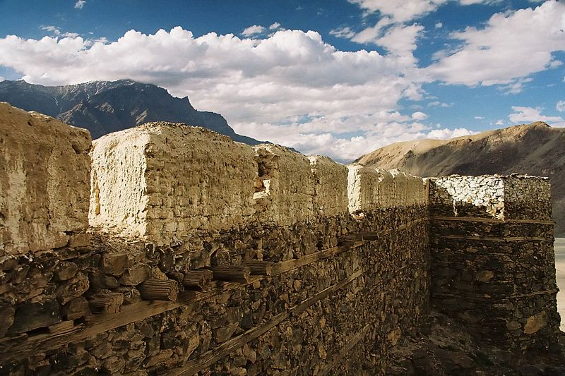

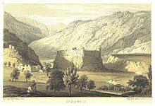

**Skardu Fort** or **Kharpocho** **The king of Forts** is a fort in Skardu city in Gilgit-Baltistan region of Pakistan. Australian mountaineer and film maker Greg Child writes that the fort is "perched above the junction of the rivers" and overlooks the Rock of Skardu. The fort was built by the king Ali Sher in the end of the sixteenth century. General Zorawar Singh of the Dogra Rajput clan working under Maharaja Gulab Singh realized the importance of the fort's location in the town and so he occupied the fort. It was part of his many military campaigns to annex the areas of Baltistan to the princely state of Jammu and Kashmir. The fort was razed to the ground in 1857 under the guidance of Ranbir Singh. Mughal emperor Aurangzeb also tried to occupy the fort, which went in vain.